OS overview

- Introduction about OS.
What is OS
operating system is interface between hardware and user.
Or
operating system is system software that manages the computer hardware and software resources.
OS = kernel + Application software.
Application software = all applications present In os.
Kernel = collection of drivers (drivers= small piece od code)
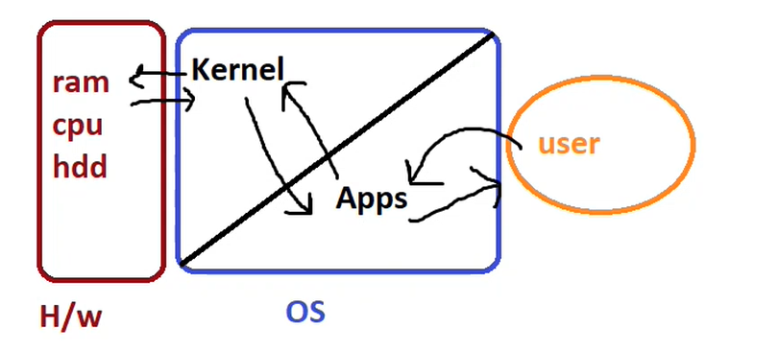
- Types of OS .
- Linux
- Window
- Unix
comparison table of different types of operating systems
Feature | Windows | Linux | Unix
Source Type | Closed Source | Open Source | Closed Source
Cost | Costly | Free | Costly
License Required | Yes | No | Yes
Security | Less Secure | Secure | Secure
Stability | Less Stable | Stable | Stable
Reliability | Not Reliable | Reliable | Reliable
Hardware Dependency | Hardware Independent | Hardware Independent | Hardware Dependent
Discovery year |  | 1991 | 1969
Partition | Single C drive partition | Can make different partition as per need | Can make different partition as per need

Types of Linux distributions:
- Ubuntu
- Redhat
- Centos
- Kali linux
- Amazon linux
- Fedora
Redhat OS - 1993
in the initial stage there is to much bugs as well security vulnerability in this code so Rdhat collects the feedback from clients and work on this and make the stable version of redhat os which is RHEL 2 (redhat enterprise linux)
in this what happened it is free to use to all but after you facing any problem we are ready guide you or support you but for this support you need pay.
this is getting more popular for their support.
like in RHEL provides both community as well official support but other distribution not have the official support it provide only community support.
community support = number of blogs over internet about solving issue related to os. But not guranted this can be solve.
official support = there is train team which is give support for you problem and it’s guranted to solve your problem.
another reason that RHEL is more popular is for there certification.
first certification is RHCT – 1999 (rehat certified technician )
now is RHCSA – Redhat certified system administrator. Exam is synario based not an MCQ types that’s why this certification have value.
Usages of certification: 82% of job opening of popular site contain redhat certified required.
and over 200 countries have red hat certified professional.
Redhat products
1. RHEL
2) red hat openshift platform
3) red hat openstack platform
4) redhat virtulization
5) red hat ansible
RHEL version and lifecycle support:-
Red Hat provides a 10-year lifecycle for each major RHEL release, split into two main phases:
- Full Support Phase (Years 1–5)
- Maintenance Support Phase (Years 6–10)

RHEL Version | Release Date | Full Support Ends | Maintenance Support Ends | EOL (End of Life)
RHEL 10 | May 2025 | May 2030 (est.) | May 2035 (est.) | May 2035+
RHEL 9 | May 2022 | May 2027 | May 2032 | May 2032+
RHEL 8 | May 2019 | May 2024 ✅ | May 2029 | May 2029+
RHEL 7 | June 2014 | Aug 2019 ✅ | June 2024 ❌ (ended) | June 2026
RHEL 6 | Nov 2010 | May 2017 ✅ | June 2020 ✅ | ❌ EOL June 2024
Redhat certification:
- Red Hat Certified System Administrator (RHCSA):
- Red Hat Certified Engineer (RHCE)
- Red Hat Certified Architect (RHCA)
- Red Hat Certified Specialist in Ansible Automation
- Red Hat Certified Specialist in OpenShift Administration
- Red Hat Certified Specialist in Security
- Red Hat Certified Specialist in Virtualization.

Feature | RHEL 8 | RHEL 9 | RHEL 10
Release Year | 2019 | 2022 | 2024 (Beta/GA expected in 2025)
Kernel Version | 4.18 | 5.14 | 6.12
Performance | Stable | Faster and optimized | Faster and modern
Upgrade path | Upgrade to RHEL 9 only | Upgrade to 10 | Latest version
Supports end | 2029 | 2032 | 2035+

